Case 5-Asia-China-Hongshan-Jade-Hook Cloud-Gōu yú-勾云-Pendant, Dadianzi, Aohan Banner, Liaoning, ca. 2000-1500 BCE

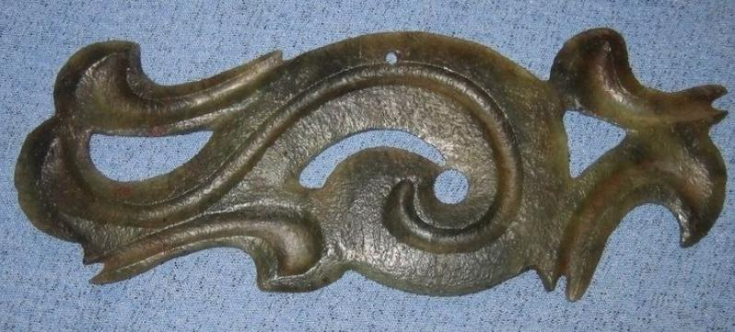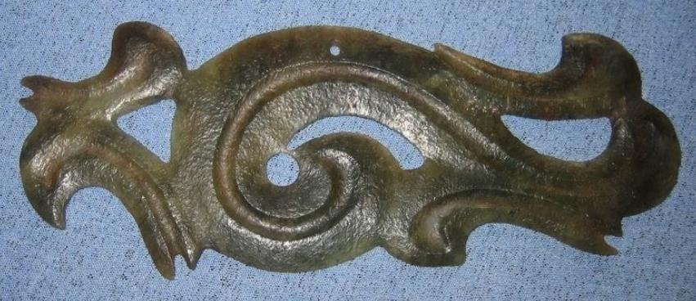

Figs. 1-2. China-Hongshan-Jade-Hook Cloud-Gōu yú-勾云-Pendant, Dadianzi, Aohan Banner, Liaoning, ca. 2000-1500 BCE

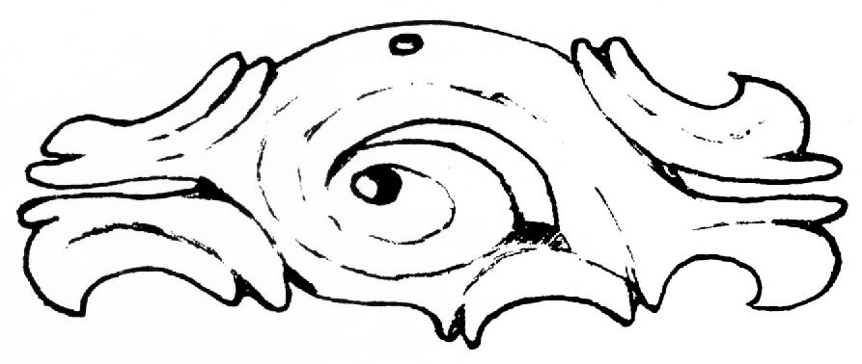

Fig. 3 China-Hongshan-Jade-Hook Cloud-Gōu yú-勾云-Pendant, Dadianzi, Aohan Banner, Liaoning, ca. 2000-1500 BCE. Drawing by Jenny So of a hooked cloud scroll pendant from Dadianzi, Aohan Banner, Liaoning, ca. 2000-1500 BCE, width 10 cm. Now in the Inner Mongolia Provincial Museum, Hohhot, after So 1993, Fig. 9b.

**Case no.: 5**

**Accession Number:**

**Formal Label:** China-Hongshan-Jade-Hook Cloud-Gōu yú-勾云-Pendant, Dadianzi, Aohan Banner, Liaoning, ca. 2000-1500 BCE

**Display Description:** This hooked cloud scroll pendant from Dadianzi, Aohan Banner, Liaoning is associated with Hongshan jades which present distinctive features and which are not associated with any other Neolithic culture. Its function as a pendant is made evident by the suspension hole pierced on the top, long side. These Gōu yú were placed in the chest area of the deceased, such as in tombs nos. 2 and 14 of the Niuheliang site. Its Chinese name, Gōu yú or ‘hook-cloud’ takes its inspiration from the abstract curvilinear shape of these pendants, which surround a central curved, spiraling, C-shape from which protrude short, hooked protuberances.

The cultural significance of Gōu yú-勾云 pendants may have been associated with shamanism since clouds represent the heavens to which the shaman aspires and the hook or the curling central section has a similar profile as the ‘dragon-pig’ pendants. This would associate the heavens with the ontology of the domesticated wild boar.

The fine grooves incised on the surface and smoothly polished, are the suggested attributes of smooth cumulus clouds also serve to consolidate all the constituent elements of the pendant.

**LC Classification:**

**Date or Time Horizon:**

**Geographical Area:** Dadianzi, Aohan Banner, Liaoning

**Map:**

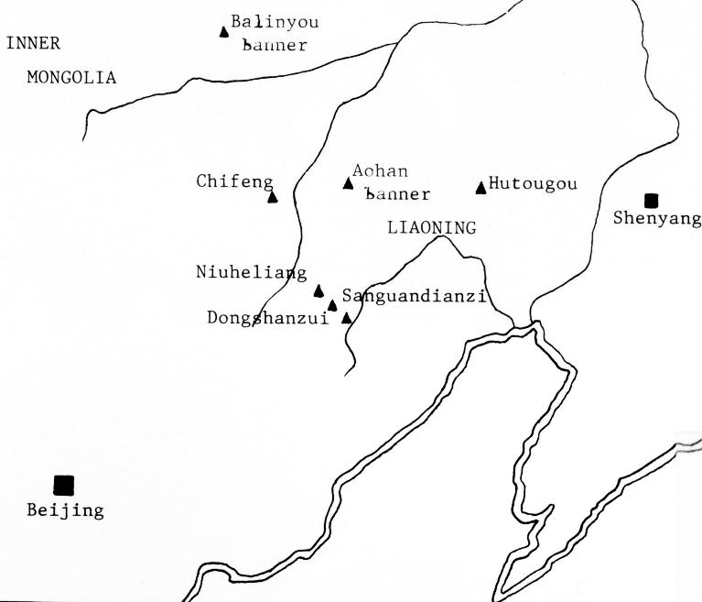

Fig. Map showing placement of Hongshan related sites after So 1993, Fig. 2.

**GPS coordinates:** 42° North , 120° East (est.)

**Cultural Affiliation:** Hongshan

**Medium:** jade

**Dimensions:** width, 13.3 cm., height 5.0 cm., thickness 0.2cm.

**Weight:** weight 25gm.

**Condition: original.**

**Provenance:** From an old private Swiss collection.

**Discussion:**

Similar ornaments excavated from tombs of the Niuheliang site. See Liaoning 1997 and Yang, 2000: entry no. 18.

**References:**

Anderson, E. N., JR. I988. *The food of China.* New Haven: Yale University Press.

Blench, Roger. 2004. “Human migrations in continental East Asia and Taiwan: genetic, linguistic and archaeological evidence. Université de Genève” [DRAFT CIRCULATED FOR COMMENT]

Chang K. C. I977. *Food in Chinese culture*. New Haven: Yale University Press.

1986. 4th edition. *The archaeology of ancient China*. New Haven: Yale University Press.

Chang K. C. 1989. "Ancient China and its anthropological significance." In *Archaeological thought in America*. Edited by C. C. Lamberg-Karlovsky, pp. I 55-66. Cambridge: Cambridge University Press.

Childs-Johnson, Elizabeth (1991). "Jades of the Hongshan culture: the dragon and fertility cult worship," Arts asiatiques, **46**: 82–95.

Cohen, M. N., and G. J. Armelagos.1. *Paleopathology at the origins of agriculture*. Orlando: Academic Press.

Freid, M. H. I967. The evolution of political society. New York: Random House.

Freidman, J., and M. J. Rowlands. I978. "Notes towards an epigenetic model of 'civilization,"' in *The evolution of social system*. Edited by J. Friedman and M. Rowlands, pp. 20I-76. London: Duckworth.

Gao, G. I978. “Dawenkou culture its nature and chronology” (大汶口文化的性质和年代), *Kuangmingribao*, April 27.

Guo, Da-Shun 1995. Hongshan and related cultures. In: *The archaeology of Northeast China: beyond the Great Wall.* Nelson, Sarah M. ed. 21-64. London and New York: Routledge.

Guo D. *Hongshan Culture(红山文化*). Artifacts Press; Beijing: 1985.

Jiang W, et al. 2006. Reconstruction of climate and vegetation changes of Lake Bayanchagan (Inner Mongolia): Holocene variability of the East Asian monsoon. Quat Res. 65(3):411–420.

Jin, G. and Liu, D. 2002. Mid-Holocene climate change in North China, and the effect on cultural development. *Chinese Science Bulletin*, *47*(5), pp.408-413.

Jing Y, Flad R. 2002.” Pig domestication in ancient China,”. Antiquity 76: 724–732.

Jing Y, Jianlin H, Blench R. 2008. “Livestock in ancient China: an archaeo-zoological perspective.” In: Sanchez-Mazas A, Blench RM, Ross M, eds. Human Migrations in Continental East Asia and Taiwan. Genetic, Linguistic and Archaeological Evidence. Routledge; Abingdon: New York.

Johnson, A. W., and T. Earle I987. *The evolution of human society: From foraging group to agrarian state*. Stanford: Stanford University Press.

Keibel F. 1897. *Normentafeln zur Entwicklungsgeschichte der Wirbelthiere*, (*Sus scrofa domesticus*). Bd. 1. Jena: Fisher, v. 1, pl. 2, no. 16.

Kaogu. I979. “Summary of the debate on the nature of Dawenkou society and related questions (关于大汶口社会性质辩论及相关问题的总结),” *Kaogu*, no. I, pp. 33-36.

Larson G, Dobney K, Albarella U, Fang M, Matisoo-Smith E, Robins J et al. 2005. “Worldwide phylogeography of wild boar reveals multiple centers of pig domestication,” *Science* 307: 1618–1621.

Larson G, Liu R, Zhao X, Yuan J, Fuller D, Barton L et al. 2010. « Patterns of East Asian pig domestication, migration, and turnover revealed by modern and ancient DNA,” *Proc Natl Acad Sci USA* 107: 7686–7691.

Lee, Y. I96I. “Mortuary practices of Wa people and the research on burial practices in prehistoric China (佤族的太平间做法，在中国史前丧葬习俗研究),” *Kaogu*, no. 7, pp. 37I-74.

Liaoning archaeological institute. 1997. Niuheliang Hongshan wenhua yizhi yu yuqi jingcui (A short presentation of the Niuheliang archaeological site, Hongshan culture, and its jades), Beijing, plates 11 - 15.

Rappaport, R. 1967. *Pigs for the ancestors*. New Haven: Yale University Press.

Sahlins, M. A. I970. "Poor man, rich man, big-man, chief: Political types in Melanesia and Polynesia," in *Cultures of the Pacific*. Edited by T. G. Harding and B. J. Wallace, pp. 203-I5. New York: Free Press.

Sahlins, M. A. I972. Stone Age economics. New York: Aldine.

Sanders, W. T., and D. Webster. I978. "Unilinealism, multilinealism, and the evolution of complex societies," in *Social archaeology: Beyond subsistence and dating*. Edited by C.

Redman, M. Berman, E. Curtis, W. Langhorne, N. Veraggi, and J. Wanser, pp. 249-302. New York: Academic Press.

Saxe, A. I970. *Social dimensions of mortuary practices*. Ann Arbor: University Microfilms.

Service. 1962. *Primitive social organization*. New York: Random House.

I975. *Origins of the state and civilization*. New York: Norton.

Shandong Provincial Museum. *I978.* “Remarks on Dawenkou culture (论大汶口文化),” *Wenwu,* no. 4, pp. 58-66.

Tang, L. I977. Origins of earliest culture in China as seen from the writing on pottery (从陶器文字看中国最早的文化起源). *Kuangmingribao*, July I4.

Tang, L. I978. “A discussion of the nature of the Dawenkou culture and the writing on pottery (论大汶口文化的性质与陶瓷文字),” *Kuangmingribao,* February 23.

Taylor, D. I975. “Some locational aspects of middle-range hierarchical societies.” Ph.D. diss., City University of New York.

Tong C. I974. “The origins of private ownership and social stratification in Chinese archaeology,” *Kaogu,* no. 4, pp. 2I3-2I.

Wang, R. I98I. “The religious significance of interring pig carcasses in the Chinese Neolithic (中国新石器时代中国猪尸屠体的宗教意义),” *Wenwu*, no. 2, pp. 79-85.

Wei, J. I976. “Discussion of origins of hierarchical societies in ancient China: An analysis of archaeological data in prehistoric societies (中国古代等级制社会的起源：史前社会考古资料分析),” *Wenwu*, no. 8, pp. I-5.

Wu, J. 1982. “The chronology of Shandong archaeology and related questions (山东考古年表及相关问题),” *Wenwu*, no. IO, pp. 44-56.

Wright, H. I984. "Pre-state political formations," in *On the evolution of complex societies*. Edited

by T. Earle, pp. 47-77. Malibu: Undena.

Yang, Xiaoneng ed. *The Golden Age of Chinese Archaeology*. New Haven, CT: Yale University Press.

Yang, X., L.A. Scuderi, X. Wang, L.J. Scuderi, D. Zhang D., H. Li, S. Forman, Q. Xu, R. Wang,

W. Huang, S. Yang. 2015. “Groundwater sapping as the cause of irreversible desertification of Hunshandake Sandy Lands, Inner Mongolia, northern China,” [*Proc Natl Acad Sci U S A*.](https://www.ncbi.nlm.nih.gov/pubmed/25561539)  Jan 20;112(3):702-6.

Zhang, Z. I979. “The breeding of domesticated pigs and its development seen from the excavated artifacts in our country (从我国出土的文物看家养猪的繁殖及其发展inese),” *Wenwu*, no. I, pp. 82-92.

Zhong, L. I976. “Origins of private ownership in prehistoric Jiangsoo province (in Chinese),” *Kaog*u, no. 3, pp. I65-67.

**References**

Anderson DC. Hongshan Jade Treasures: The Art, Iconography and Authentication of Carvings from China’s Finest Neolithic Culture. Tau Publishing; Fraz. Pian di Porto, Todi, Italy: 2012.

Anderson, E. N., JR. I988. *The food of China.* New Haven: Yale University Press.

Blench, Roger. 2004. “Human migrations in continental East Asia and Taiwan: genetic, linguistic and archaeological evidence. Université de Genève” [DRAFT CIRCULATED FOR COMMENT]

Booth R, et al. A severe centennial-scale drought in mid-continental North America 4200 years ago and apparent global linkages. Holocene. 2005;15(3):321–328.

Chang K. C. I977. *Food in Chinese culture*. New Haven: Yale University Press.

1986. 4th edition. *The archaeology of ancient China*. New Haven: Yale University Press.

1989. "Ancient China and its anthropological significance." In *Archaeological thought in America*. Edited by C. C. Lamberg-Karlovsky, pp. I 55-66. Cambridge: Cambridge University Press.

Childs-Johnson, Elizabeth (1991). "Jades of the Hongshan culture: the dragon and fertility cult worship," Arts asiatiques, **46**: 82–95.

Cui H, Liu H, Yao X. The finding of a paleo-spruce timber in Hunshandak Sandy Land and its paleoecological significance. Science in China. 1997;40(6):599–604.

Cohen, M. N., and G. J. Armelagos.1. *Paleopathology at the origins of agriculture*. Orlando: Academic Press.

Freid, M. H. I967. The evolution of political society. New York: Random House.

Freidman, J., and M. J. Rowlands. I978. "Notes towards an epigenetic model of 'civilization,"' in *The evolution of social system*. Edited by J. Friedman and M. Rowlands, pp. 20I-76. London: Duckworth.

Gao, G. I978. “Dawenkou culture its nature and chronology” (大汶口文化的性质和年代), *Kuangmingribao*, April 27.

Geirsdóttir A, Miller G, Larsen DJ, Ólafsdóttir S. Abrupt Holocene climate transitions in the northern North Atlantic region recorded by synchronized lacustrine records in Iceland. Quat Sci Rev. 2013;70:48–62.

Guo, Da-Shun 1995. Hongshan and related cultures. In: *The archaeology of Northeast China: beyond the Great Wall.* Nelson, Sarah M. ed. 21-64. London and New York: Routledge.

Guo D. *Hongshan Culture(红山文化*). Artifacts Press; Beijing: 1985.

Huang J, Wang S, Wen X, Yang B. Progress in studies of the climate of Humid Period and the impacts of changing precession in early-mid Holocene. Prog Nat Sci. 2008;18(12):1459–1464.

Jiang W, et al. 2006. Reconstruction of climate and vegetation changes of Lake Bayanchagan (Inner Mongolia): Holocene variability of the East Asian monsoon. Quat Res. 65(3):411–420.

Jin, G. and Liu, D. 2002. Mid-Holocene climate change in North China, and the effect on cultural development. *Chinese Science Bulletin*, *47*(5), pp.408-413.

Jin G, Liu D. Mid-Holocene climate change in North China and the effect on cultural development. Chin Sci Bull. 2002;47(5):408–413.

Jing Y, Flad R. 2002.” Pig domestication in ancient China,”. Antiquity 76: 724–732.

Jing Y, Jianlin H, Blench R. 2008. “Livestock in ancient China: an archaeo-zoological perspective.” In: Sanchez-Mazas A, Blench RM, Ross M, eds. Human Migrations in Continental East Asia and Taiwan. Genetic, Linguistic and Archaeological Evidence. Routledge; Abingdon: New York.

Johnson, A. W., and T. Earle I987. *The evolution of human society: From foraging group to agrarian state*. Stanford: Stanford University Press.

Keibel F. 1897. *Normentafeln zur Entwicklungsgeschichte der Wirbelthiere*, (*Sus scrofa domesticus*). Bd. 1. Jena: Fisher, v. 1, pl. 2, no. 16.

Kaogu. I979. “Summary of the debate on the nature of Dawenkou society and related questions (关于大汶口社会性质辩论及相关问题的总结),” *Kaogu*, no. I, pp. 33-36.

Larson G, Dobney K, Albarella U, Fang M, Matisoo-Smith E, Robins J et al. 2005. “Worldwide phylogeography of wild boar reveals multiple centers of pig domestication,” *Science* 307: 1618–1621.

Larson G, Liu R, Zhao X, Yuan J, Fuller D, Barton L et al. 2010. « Patterns of East Asian pig domestication, migration, and turnover revealed by modern and ancient DNA,” *Proc Natl Acad Sci USA* 107: 7686–7691.

Lee, Y. I96I. “Mortuary practices of Wa people and the research on burial practices in prehistoric China (佤族的太平间做法，在中国史前丧葬习俗研究),” *Kaogu*, no. 7, pp. 37I-74.

Liu H, Xu L, Cui H. Holocene history of desertification along the woodland-steppe border in northern China. Quat Res. 2002;57(2):259–270.

Liu F, Feng Z. A dramatic climatic transition at ∼4000 cal. yr BP and its cultural responses in Chinese cultural domains. Holocene. 2012;22(10):1181–1197.

Rappaport, R. 1967. *Pigs for the ancestors*. New Haven: Yale University Press.

Sahlins, M. A. I970. "Poor man, rich man, big-man, chief: Political types in Melanesia and Polynesia," in *Cultures of the Pacific*. Edited by T. G. Harding and B. J. Wallace, pp. 203-I5. New York: Free Press. . I972. Stone Age economics. New York: Aldine.

Sanders, W. T., and D. Webster. I978. "Unilinealism, multilinealism, and the evolution of complex societies," in *Social archaeology: Beyond subsistence and dating*. Edited by C. Redman, M. Berman, E. Curtis, W. Langhorne, N. Veraggi, and J. Wanser, pp. 249-302. New York: Academic Press.

Saxe, A. I970. *Social dimensions of mortuary practices*. Ann Arbor: University Microfilms.

Scheffer M, Carpenter S, Foley JA, Folke C, Walker B. Catastrophic shifts in ecosystems. Nature. 2001;413(6856):591–596.

Service. 1962. *Primitive social organization*. New York: Random House.

I975. *Origins of the state and civilization*. New York: Norton.

Shandong Provincial Museum. *I978.* “Remarks on Dawenkou culture (论大汶口文化),” *Wenwu,* no. 4, pp. 58-66.

Tang, L. I977. Origins of earliest culture in China as seen from the writing on pottery (从陶器文字看中国最早的文化起源). *Kuangmingribao*, July I4.

I978. “A discussion of the nature of the Dawenkou culture and the writing on pottery (论大汶口文化的性质与陶瓷文字),” *Kuangmingribao,* February 23.

Taylor, D. I975. “Some locational aspects of middle-range hierarchical societies.” Ph.D. diss., City University of New York.

Tong C. I974. “The origins of private ownership and social stratification in Chinese archaeology,” *Kaogu,* no. 4, pp. 2I3-2I.

Wagner M, et al. Mapping of the spatial and temporal distribution of archaeological sites of northern China during the Neolithic and Bronze Age. Quat Int. 2013;290/291:344–357.

Wang, R. I98I. “The religious significance of interring pig carcasses in the Chinese Neolithic (中国新石器时代中国猪尸屠体的宗教意义),” *Wenwu*, no. 2, pp. 79-85.

Wei, J. I976. “Discussion of origins of hierarchical societies in ancient China: An analysis of archaeological data in prehistoric societies (中国古代等级制社会的起源：史前社会考古资料分析),” *Wenwu*, no. 8, pp. I-5.

Wu, J. 1982. “The chronology of Shandong archaeology and related questions (山东考古年表及相关问题),” *Wenwu*, no. IO, pp. 44-56.

Wright, H. I984. "Pre-state political formations," in *On the evolution of complex societies*. Edited by T. Earle, pp. 47-77. Malibu: Undena.

Yang X, et al. Initiation and variation of the dune fields in semi-arid northern China—with a special reference to the Hunshandake Sandy Land, Inner Mongolia. Quat Sci Rev. 2013;78:369–380.

Yang, X., L.A. Scuderi, X. Wang, L.J. Scuderi, D. Zhang D., H. Li, S. Forman, Q. Xu, R. Wang, W. Huang, S. Yang. 2015. “Groundwater sapping as the cause of irreversible desertification of Hunshandake Sandy Lands, Inner Mongolia, northern China,” [*Proc Natl Acad Sci U S A*.](https://www.ncbi.nlm.nih.gov/pubmed/25561539)  Jan 20;112(3):702-6.

Yang X, Scuderi LA. Hydrological and climatic changes in deserts of China since the late Pleistocene. Quat Res. 2010;73(1):1–9.

Zhao Y, Yu Z. Vegetation response to Holocene climate change in East Asian monsoon-margin region. Earth Sci Rev. 2012;113(1-2):1–10.

Zhang, Z. I979. “The breeding of domesticated pigs and its development seen from the excavated artifacts in our country (从我国出土的文物看家养猪的繁殖及其发展inese),” *Wenwu*, no. I, pp. 82-92.

Zhong, L. I976. “Origins of private ownership in prehistoric Jiangsoo province (in Chinese),” *Kaog*u, no. 3, pp. I65-67.